DS LAB – 5

Name – Rahul Ponnuru

SY – CS - C

Roll No – 55

Prn No – 12011370

Lab No – 5

Title – Linear Regression

* Importing Necessay Libraries

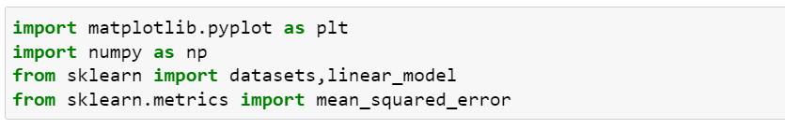

* Taking dataset from sklearn library





